Evidence-Centered Classroom Assessment – Skill Rubric
Skill Name:
Figurative language
Description:

CCSS.ELA-LITERACY.RL.5.4
Determine the meaning of words and phrases as they are used in a text, including figurative language such as metaphors and similes.
Height  Levels of  Performance | Description of Skill  What will students be able to do if they are demonstrating the skill? | Assignment Characteristics  What will show you that students have the skills you are looking for? | Activity Characteristics  What do students need to do in order to generate the required evidence?
Advanced | Compare different meanings of figurative language & create your own examples of figurative language. | Compare examples of figurative language & create examples of figurative language.  Created examples are novel and creative. | Read and analyze a text AND create their own examples with at least 80% accuracy.
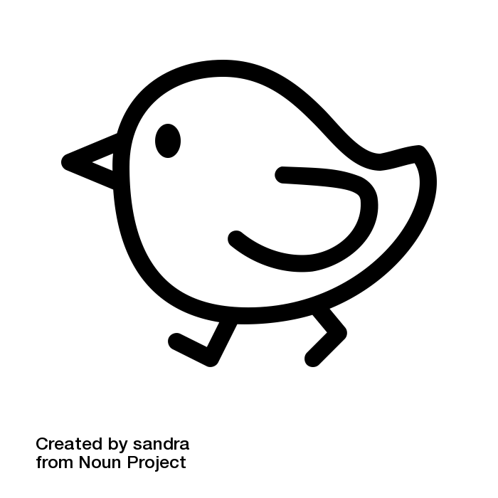  Proficient | Interpret each example of figurative language in the text. | Interpret examples of figurative language  Created examples are appropriate and different from examples supplied in material. | Read & analyze a text by interpreting the multiple examples of figurative language with at least 80% accuracy.
Approaching | Identify examples of figurative language in the text. | Identify examples of figurative language.  Created examples are minor variations on examples supplied by instructors. | Read & analyze a text by properly identifying multiple examples of figurative language with at least 80% accuracy.
Links to other skills:

Related Standards and Objectives:

